**Transformers**

**What Are Transformers?**

Transformers are a type of **deep learning model** primarily used for processing and understanding sequences of data. They have revolutionized fields like **natural language processing (NLP)** and are behind many smart technologies like chatbots, language translators, and even image recognition tools.

Unlike older models that read data step-by-step (like Recurrent Neural Networks or RNNs), transformers can look at all parts of the data at the same time. This ability makes them faster and more powerful for many tasks.

**Why Are Transformers Important?**

Before transformers, models struggled with:

* **Long sentences or long sequences:** Older models had trouble remembering information from earlier in the sequence.
* **Slow processing:** Reading sequences one step at a time took a long time.

Transformers solved these problems by allowing models to process the entire sequence simultaneously and focus on important parts using a mechanism called **attention**.

**The Basic Idea: How Do Transformers Work?**

At a high level, a transformer model takes an input sequence (like a sentence), processes it through several layers, and produces an output (like a translation or a summary).

Here’s a simple breakdown:

1. **Input Embedding:** The input words are converted into numerical vectors called embeddings. These vectors represent the meaning of words in a way the model can understand.
2. **Positional Encoding:** Since transformers process all words at once, they need a way to understand the order of words. Positional encoding adds information about word positions to the embeddings.
3. **Attention Mechanism:** This is the core part. It allows the model to “pay attention” to different words in the input when processing each word. For example, when understanding the word “it” in a sentence, the model can look back to the word it refers to.
4. **Feed-Forward Layers:** After attention, the data passes through some simple neural network layers to help the model learn complex patterns.
5. **Output:** Finally, the transformer produces an output, such as a translated sentence or the next word in a text.

**Deep Dive: The Transformer Architecture**

The transformer model was introduced in 2017 by Vaswani et al. in the paper titled **"Attention is All You Need."** It changed the way machines understand sequences by relying completely on the **attention mechanism**, without using any recurrent or convolutional layers.

The transformer consists of two main parts:

* **Encoder** — processes the input sequence.
* **Decoder** — generates the output sequence.

Both the encoder and decoder are made up of multiple identical layers stacked on top of each other. Let’s look closer at each component.

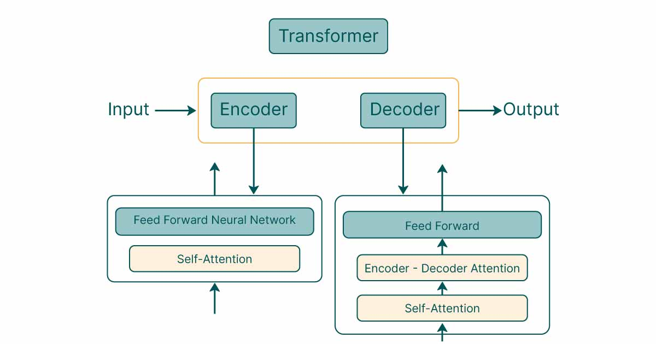

**1. Encoder**

The encoder’s job is to take the input sequence (like a sentence) and convert it into a rich, numerical representation that captures meaning and context.

Each encoder layer has two main parts:

* **Multi-Head Self-Attention**
* **Feed-Forward Neural Network**

**Multi-Head Self-Attention**

This is the core of the transformer. It lets the model focus on different parts of the input sentence simultaneously. But what does that mean?

Imagine you want to understand the sentence:

*"The cat sat on the mat because it was tired."*

When processing the word **"it"**, the model needs to know what “it” refers to. The attention mechanism allows the model to look at the word **"cat"** to get the right context.

**How it works:**

* The model creates three vectors for each word: **Query (Q)**, **Key (K)**, and **Value (V)**.
* Attention scores are calculated by comparing the Query vector of one word to the Key vectors of all words in the sentence.
* These scores determine how much focus (or attention) to give each word when processing a particular word.
* The weighted sum of the Value vectors gives the attention output.

“Multi-head” means the model does this process multiple times in parallel with different sets of Q, K, and V vectors, allowing it to focus on different parts of the sentence at once.

**Feed-Forward Neural Network**

After the attention step, the output passes through a small feed-forward neural network (the same for every position). This helps the model learn more complex patterns.

**2. Decoder**

The decoder is responsible for generating the output, like translating a sentence into another language or predicting the next word.

Each decoder layer has three parts:

* **Masked Multi-Head Self-Attention:** Similar to the encoder’s attention but “masked” so the model can only attend to earlier words when generating output. This prevents it from cheating by looking ahead.
* **Multi-Head Attention over Encoder Output:** This lets the decoder pay attention to the encoder’s output, combining information from the input sequence with what it has generated so far.
* **Feed-Forward Neural Network:** As in the encoder, this helps the model learn complex features.

**3. Positional Encoding**

Since transformers process all words simultaneously, they have no inherent sense of word order. To fix this, **positional encodings** are added to the input embeddings.

These encodings inject information about each word’s position in the sequence so the model knows the difference between, for example, “The cat sat” and “Sat the cat.”

Positional encoding usually involves adding sine and cosine functions of different frequencies to each embedding vector, which helps the model learn position-based relationships.

**Applications of Transformers**

Transformers are used everywhere! Here are some popular uses:

* **Language Translation:** Google Translate uses transformers to convert text from one language to another.
* **Text Summarization:** Creating short summaries of long documents.
* **Chatbots and Virtual Assistants:** Like me! We use transformers to understand and generate human-like responses.
* **Text Generation:** Writing articles, stories, or even computer code.
* **Image Processing:** Transformers are now being used for image recognition and generation, expanding beyond text.

**Summary**

* Transformers introduced a new way to process sequences using the attention mechanism.
* They handle long-range dependencies better than previous models.
* Their architecture consists of stacked encoders and decoders, relying heavily on multi-head self-attention.
* Positional encoding allows them to understand the order of words.
* Transformers power many modern AI applications, making machines better at understanding and generating human language.